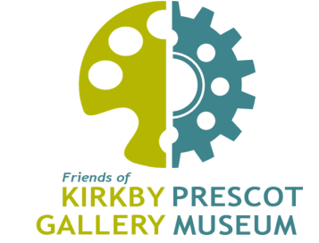
Affordable Art Auction
Kirkby Gallery Thursday 9 May, 5pm-8pm
Absentee Bidder Registration Form

If you are unable to attend the Affordable Art Auction but wish to bid, this form must be completed and returned to Tina Ball by 10pm on Monday 6 May. We will not be taking online or telephone bids. We will then assign you a bidding number and record your bid(s) against your chosen lot(s); we will not exceed your maximum bid. You will be notified by email at the close of sale if you have been successful.
Please note that if you are the highest bidder, you will only pay the price you have bid; the commission on the artworks will be deducted from the price, and goes to the Friends of Kirkby Gallery & Prescot Museum to support their subsidised and free activities for the community.
Successful bidders must collect their purchase(s) from Kirkby Gallery on either Friday 10 or Saturday 11 May between 10am and 12noon; payment must be made in either cash or cheque (made payable to Friends of Kirkby Gallery & Prescot Museum).

1. I understand that the goods are sold in an “as is” condition and confirm that I will satisfy myself as to the condition of the same prior to bidding.
2. I accept payment is due immediately following the fall of the hammer and confirm I have sufficient funds and authority to make a purchase.
Name (Print in Block Capitals):
Signature: Date:
Company Name (if applicable):
Address (including postcode):

Telephone Number:
LOT No. | Artist | Title | Max. Bid
Email Address:

Please send completed forms to tina.ball@knowsley.gov.uk

