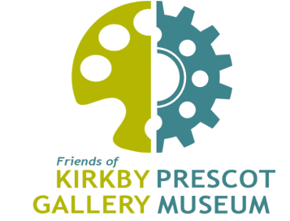
Affordable Art Auction
Kirkby Gallery Thursday 9 May, 5pm-8pm
Bidder Registration Form

This form must be completed in order to bid on artworks in the Affordable Art Auction and returned to Tina Ball by 10pm on Monday 6 May. We will then assign you a bidding number paddle which will be ready for you to collect at Kirkby Gallery between 3.45pm and 4.50pm on Thursday 9 May. By submitting this form, you are confirming your attendance at the Affordable Art Auction.
Please note that if you are the highest bidder, you will only pay the price you have bid; the commission on the artworks will be deducted from the price, and goes to the Friends of Kirkby Gallery & Prescot Museum to support their subsidised and free activities for the community.
Payment must be made in either cash or cheque (made payable to Friends of Kirkby Gallery & Prescot Museum) immediately following the sale.* For those unable to take their purchases home on the night, works may be collected from Kirkby Gallery on either Friday 10 or Saturday 11 May between 10am and 12noon. *A minimum of £100 deposit can be paid, with the balance paid on collection of artwork(s).

1. I understand that the goods are sold in an “as is” condition and confirm that I will satisfy myself as to the condition of the same prior to bidding.
2. I accept payment is due immediately following the fall of the hammer and confirm I have sufficient funds and authority to make a purchase.
Name (Print in Block Capitals):
Signature: Date:
Company Name (if applicable):
Address (including postcode):

Telephone Number:
Email Address:

Please send completed forms to tina.ball@knowsley.gov.uk

